Toucan Customer Transactions API

Implementation Documentation and Swagger UI Evidence
Generated from the running Spring Boot application on 31st August 2026.
1. Understanding of the Problem
The application manages customer transactions. Each transaction has an immutable transaction ID, a customer ID, amount, currency, transaction type, and transaction status. The service exposes exactly the four operations required by the challenge: create a transaction, retrieve one transaction, update its status, and list transactions for a customer.
The solution uses a thin REST controller, DTOs for HTTP input and output, a service for business rules, a Spring Data repository for persistence, a JPA entity for the transactions table, and H2 SQL scripts for schema creation and sample records.

2. Assumptions
Transaction IDs are natural string keys and cannot be changed after creation.
The supported transaction types are PAYMENT, REFUND, and TRANSFER.
The supported statuses are PENDING, COMPLETED, and FAILED.
Status input is case-insensitive and the shorthand complete is normalized to COMPLETED.
The H2 database is in-memory, so data is recreated when the application restarts.
Sample rows are intended for local demonstration and are loaded by data.sql at startup.

3. Validation Rules
Field
Rule
transactionId
Required, non-blank, maximum 64 characters, unique.
customerId
Required, non-blank, maximum 64 characters.
amount
Required and at least 0.01.
currency
Required, exactly three uppercase letters, such as USD.
transactionType
Required and one of PAYMENT, REFUND, or TRANSFER.
transactionStatus
Required and one of PENDING, COMPLETED, or FAILED.
The create operation requires PENDING as the initial status. A PENDING transaction may move once to COMPLETED or FAILED. Once a transaction reach COMPLETED or FAILED, it cannot be changed again. Unknown status names are rejected with HTTP 400.

4. API Endpoints
Method | Path | Purpose
POST | /api/transactions | Create and persist a transaction.
GET | /api/transactions/{transactionId} | Retrieve one transaction.
PATCH | /api/transactions/{transactionId}/status | Replace the transaction status.
GET | /api/customers/{customerId}/transactions | List a customer's transactions.

Create Request
{ "transactionId": "tx-1001", "customerId": "customer-42", "amount": 125.5, "currency": "USD", "transactionType": "PAYMENT", "transactionStatus": "PENDING"}
Status Update Request
PATCH /api/transactions/tx-1001/status{ "transactionStatus": "complete"}
The response normalizes this value to COMPLETED:
{ "transactionId": "tx-1001", "customerId": "customer-42", "amount": 125.50, "currency": "USD", "transactionType": "PAYMENT", "transactionStatus": "COMPLETED"}

Database Schema and Sample Data
CREATE TABLE transactions ( transaction_id VARCHAR(64) NOT NULL, customer_id VARCHAR(64) NOT NULL, amount DECIMAL(19, 4) NOT NULL, currency VARCHAR(3) NOT NULL, transaction_type VARCHAR(20) NOT NULL, transaction_status VARCHAR(20) NOT NULL, CONSTRAINT pk_transactions PRIMARY KEY (transaction_id));
H2 sample records loaded from data.sql:
tx-1001 | customer-42 | 125.50 USD | PAYMENT | PENDINGtx-1002 | customer-42 | 75.00 EUR | REFUND | COMPLETEDtx-1003 | customer-99 | 250.00 GBP | TRANSFER | FAILED

5. Testing Approach
Integration tests use Spring Boot, MockMvc, the real service layer, the repository, and H2. This verifies the complete request-to-database flow instead of testing the controller in isolation. The suite covers creation and retrieval, status updates, customer filtering, invalid initial status, terminal-state protection, lowercase complete input, and OpenAPI availability.
mvnw.cmd clean testResult: 8 tests passed, 0 failures, 0 errors

6. Known Limitations
H2 is in-memory and is not intended for production persistence.
The schema is recreated on startup, so sample data is reset on every restart.
There is no authentication or authorization layer.
The duplicate check is application-level; a production system should also translate database constraint violations consistently.
The API supports a small fixed set of enum values rather than arbitrary business-configured statuses.

7. Improvements With More Time
Replace H2 with a production database and use Flyway or Liquibase migrations.
Add authentication, authorization, audit fields, and request correlation IDs.
Add optimistic locking for concurrent status updates.
Return a consistent structured error DTO for malformed JSON and invalid enum values.
Add contract tests and automated API checks against the generated OpenAPI specification.

8. Swagger UI Screenshots
The following screenshots were captured from http://localhost:8080/swagger-ui.html. Use Try it out to send requests to the live H2-backed API.

8.1 Create Transaction
POST /api/transactions with the requested transaction JSON example.

8.2 Update Transaction Status
PATCH /api/transactions/{transactionId}/status with a status request body.

8.3 Get Transaction
GET /api/transactions/{transactionId}, prefilled with seeded ID tx-1001.

8.4 Get Customer Transactions
GET /api/customers/{customerId}/transactions, prefilled with seeded customer-42.

Updated Business Rule Notes
Status transitions are now enforced as a lifecycle: PENDING -> COMPLETED or FAILED is allowed once; COMPLETED and FAILED are terminal states and cannot be modified again.
Verification: .\mvnw.cmd clean test -> 8 tests passed, 0 failures, 0 errors, BUILD SUCCESS.

8. Swagger UI Screenshot
Figure: Swagger UI home page for the Customer Transactions API

8.1 Create Transaction (POST)
Endpoint: POST /api/transactions
Endpoint for creating a new transaction with required fields (transactionId, customerId, amount, currency, transactionType). Initial status is automatically set to PENDING.

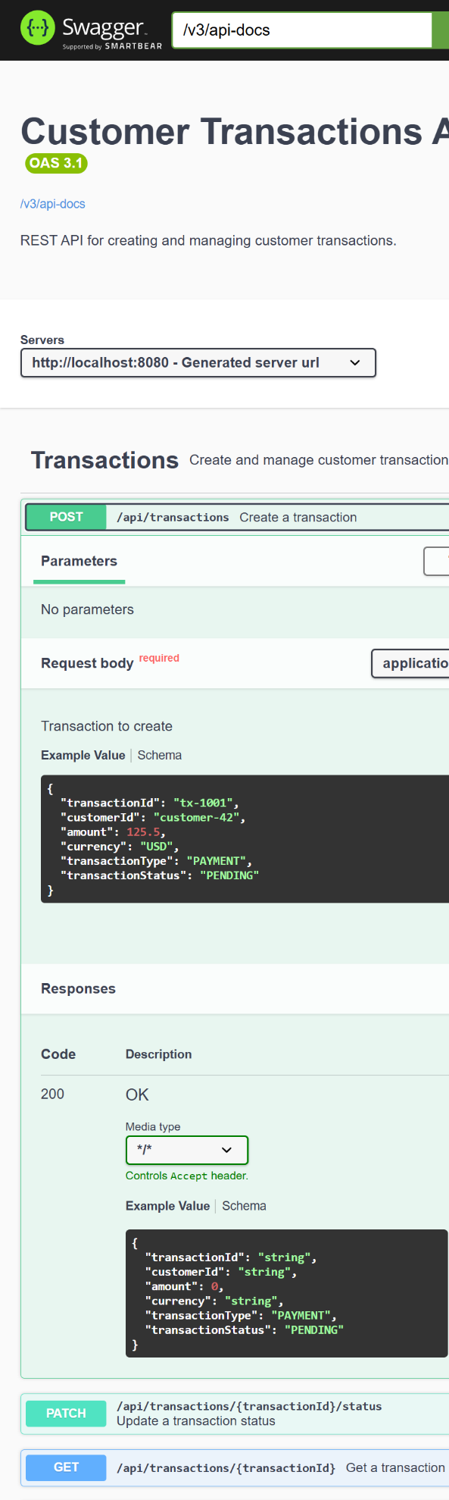
8.2 Update Transaction Status (PATCH)
Endpoint: PATCH /api/transactions/{transactionId}/status
Update transaction status. PENDING transactions can transition to COMPLETED or FAILED. Terminal states (COMPLETED, FAILED) cannot be changed.
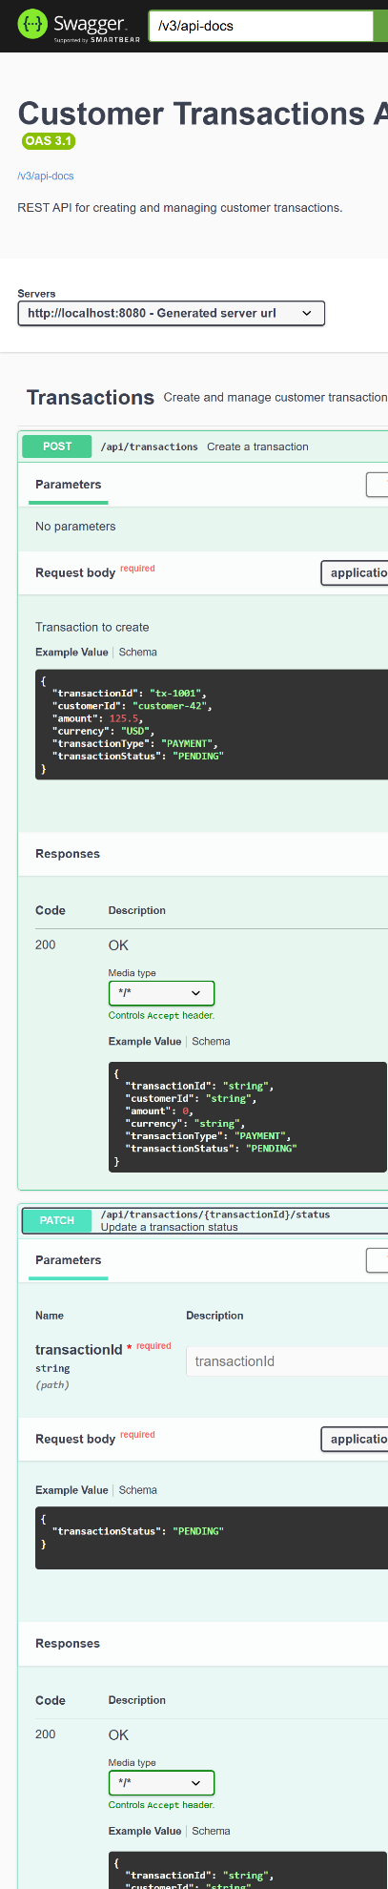

8.3 Get Transaction (GET)
Endpoint: GET /api/transactions/{transactionId}
Retrieve a specific transaction by its ID. Returns 200 OK with transaction details or 404 Not Found.
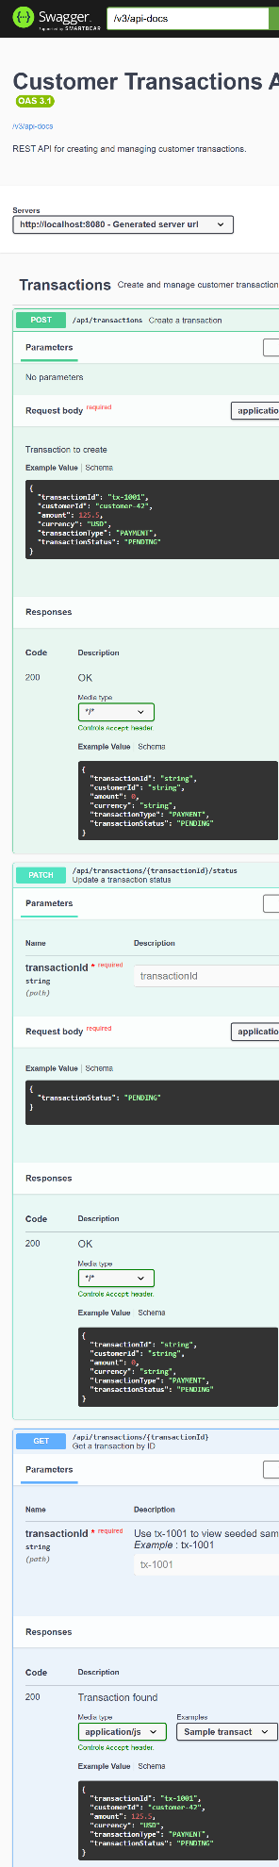

8.4 List Customer Transactions (GET)
Endpoint: GET /api/customers/{customerId}/transactions
List all transactions for a specific customer, ordered by transaction ID. Returns empty array if customer has no transactions.
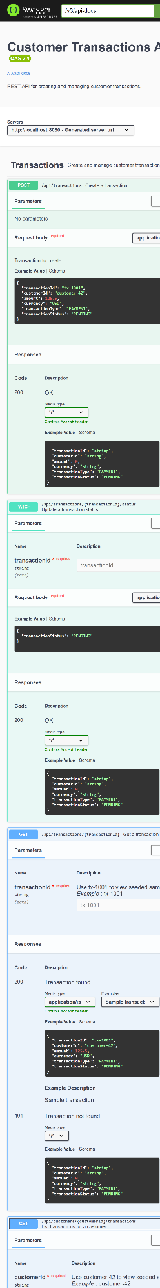
9. AI usage disclosure
GitHub Copilot was used to help organize packages, add OpenAPI configuration, create the SQL schema and sample data, improve documentation, and review test coverage. Used AI to review my code and enhance validations along with running the Maven test suite, and correcting package and H2 initialization issues found during validation.

